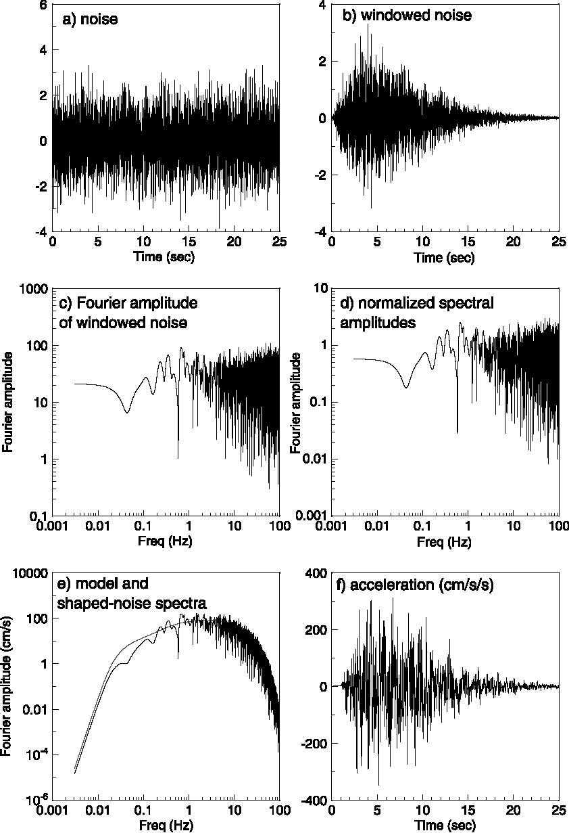

Figure ‑: Ground motion simulation steps in stochastic method, starting “a” through “f” (after Boore 2003).

General steps of ground motion simulation are shown in Figure ‎2‑3. First a white noise (Gaussian or uniform) is generated for a duration given by the duration of the motion (Figure ‎2‑3a); this noise is then windowed by a intensity function (Figure ‎2‑3b); the windowed noise is transformed into the frequency domain (Figure ‎2‑3c); the spectrum is normalized by the square-root of the mean square amplitude spectrum (Figure ‎2‑3d); the normalized spectrum is multiplied by the ground motion spectrum ; and the resulting spectrum is transformed back to the time domain (Figure ‎2‑3f) (Boore 2003).