Homework Set 4c

1. For the fault parameters given below, answer the following questions.

|  |  |  |
| --- | --- | --- |
| **Parameters** | **Fault A** | **Fault B** |
| Characteristic Earthquake Parameters | | |
|  | 1.0 | 0.5 |
|  | 0.5 | 1.0 |
|  | 7.8 | 7.0 |
|  | 6.0 | 6.0 |
| b-value | 0.9 | 0.9 |

Note that 

**Part I**

For each fault, find the expected value of the earthquake magnitude, *E*(m) assuming:

a) Characteristic Earthquake Model

b) Truncated Exponential Model using the value given above.

Formulas for the characteristic earthquake model are given below.

Hint: 

**Part II**

Given that an earthquake magnitude  will happen, compute for each fault, the probability that an earthquake of magnitude between 6.5 and 7.6 happens. Assume that the faults follow a characteristic earthquake model

Characteristic Earthquake Model

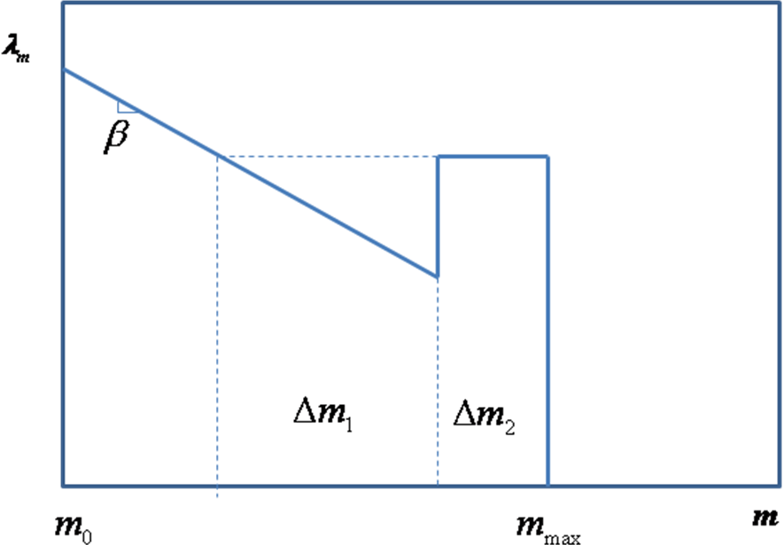

**

*Youngs and Coppersmith (1995) recommended using*