Problem Set 4
Ground Motion Variability

The source model from problem set 3 is given below:

 | Fault 1 | Fault 2
Length (km) | 100 | 30
Width (km) | 15 | 14
Dip | 90 | 45
Top of fault (km) | 0 | 5
Slip-Rate (mm/yr) | 5 | 1
Magnitude pdf | delta function | delta function
Style-of-Faulting | Strike-slip | Reverse
Mag-Area model: | mean M=log(A)+4  pdf = delta func | mean M=log(A)+4  pdf = delta func
The site is located at X=8 km

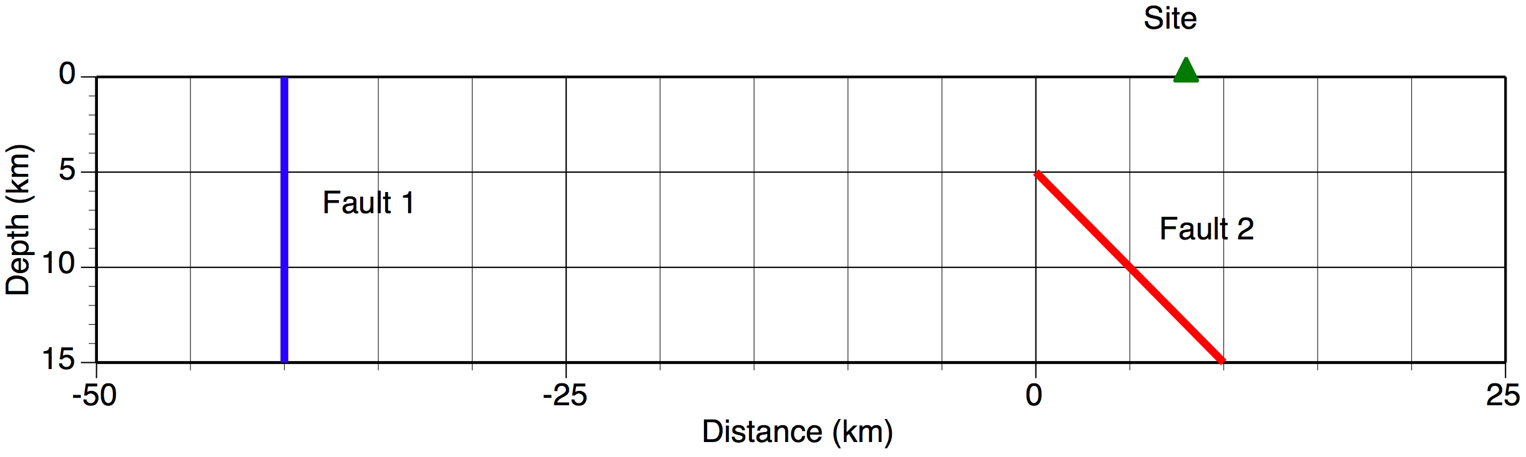

1. Using the results from problem set 3 for the rock site, discretize the ground motion distribution for discrete epsilons using a step size of 0.2 epsilon units. Compute the probability of epsilon and the corresponding value of the T=0.2 sec spectral acceleration (for the center of the range) starting at epsilon=-3.1
(e.g. range of –3.1 to –2.9, -2.9 to –2.7 …. up to 3.1)

2. Using the results from problem set 3, compute the hazard for each fault using explicit integration over epsilon using the two cases listed below (A and B). For each case, plot the hazard curve for each fault and for the total hazard curve.

(A) Assume a delta function for the ground motion variability (e.g. ignoring the ground motion variability)

(B) Include the ground motion variability using a lognormal distribution

3. Read the paper by Wang and Zhou (2007) commenting on the Bommer and Abrahamson (2006) review paper. What is the error in the Wang and Zhou paper?

4. Joe engineer wants his structure to be safe so he uses the deterministic approach for developing design ground motions. Joe says that the deterministic approach is conservative because it uses the largest magnitude at the shortest distance with a conservative estimate of the ground motion (84th percentile ground motion).
Explain to Joe what is wrong with his approach.

