introduction to earthquake engineering

Course Content and General Information
The course is presented as a series of linked modules. Modules that focus on approaches to earthquake resistant design, characterization of earthquake shaking, elastic and inelastic response of SDOF and MDOF systems to earthquake shaking, seismic analysis and evaluation of building systems, and seismic protective systems are currently planned. Each module will be uploaded to the class web site prior (see http://overlord.eng.buffalo.edu/ClassHomePages/cie619/index.htm) to the material being covered in class and each module will include reading assignments specific to that module.
Homework assignments will be uploaded to the class web site. Solutions must be submitted by the due date, else a grade of 0 points will be assigned.
The grading policy for CIE 619 is presented on the class web site. Thirty points (of 100) is assigned to homework; twenty points (of 100) is assigned to the midterm examination, and fifty points (of 100) is assigned to the final examination. A passing grade in both the homework (15 points out of 30) and the final examination (25 points out of 50) is required for a passing grade in the class.

Acknowledgements
Faculty at the University at Buffalo and the University of California at Berkeley, and expert design professionals contributed information, directly or indirectly, to the content of CIE 619. These individuals are listed below and their contributions are gratefully acknowledged.
University at Buffalo
Professor Michael Constantinou
Professor Gary Dargush
Professor Andrei Reinhorn
University of California at Berkeley
Professor Stephen Mahin
Professor Jack Moehle
Consulting Structural and Geotechnical Engineers
Ron Hamburger, ABS Consulting (formerly EQE International)
James Malley, Degenknolb Engineers

Recommended Reading
There are no assigned textbooks for CIE 619. However, a list of reference material will be assembled over the course of the semester and will be available at the class home page: cie619/index.htm/references.pdf. As noted above, additional reading material (papers, chapters from textbooks, etc.) will be assigned over the course of the semester.

History of Earthquake Engineering in the United States

Introduction
Procedures for analysis and design of buildings and bridges for seismic effects have existed in the United States for more than 70 years. A detailed history of the procedures used for buildings is presented in ATC-34 (ATC, 1995). Information on early analysis and design procedures for bridges is presented in Competing Against Time (SOC, 1990).
For buildings, earthquake effects were first recognized in the 1927 Uniform Building Code bit that Code did not prescribe any design requirements (see ATC, 1995). The 1930 edition stated: “The following provisions are suggested for inclusion in the Code by cities in areas subject to earthquake shocks. The design of buildings for earthquake shocks is a moot question but the following provisions will provide adequate additional strength when applied in the design of buildings or structures.” The requirements for design in 1930 were that a building should be designed to resist a horizontal force F at every elevation as follows:
where is a seismic coefficient and W is the dead weight plus live load above the level under consideration. The seismic coefficient has the values of 0.075 when the foundation rests on material upon which a load of 2 tons/ft2 or more is allowed and 0.10 elsewhere.
- Inclusion of soil-type dependent response coefficient
For bridges, codes of practice for the seismic design were first developed in 1940 in California by the California Department of Transportation (Caltrans). However, earthquakes were considered in the design of important bridges before the publication of the first code. In the early 1930s, earthquake shaking was considered for the design of important bridges such as the Golden Gate Bridge and the San Francisco Oakland Bay Bridge. An equation similar to that of the 1930 UBC was used to calculate the effects of earthquake shaking and was set equal to 0.10 (or 0.075 depending on the reference document) for the design of the bridges mentioned above. These values were either taken from the 1930 UBC or used a common source. In 1940, the Caltrans seismic design criteria was “Provision shall be made for seismic stresses resulting from earthquake. The seismic force shall be considered as an assumed horizontal force applied at the center of mass in any direction that will produce a maximum stress in the member considered. The assumed horizontal force shall be a percentage of the dead load and will be determined by the Designing Engineer.” The criteria were revised in 1943 to read “…structures…shall be designed to resist a seismic force (F) in accordance with the following formula: F=CW, where F is the seismic force to be applied horizontally in any direction at the center of gravity of the weight of the structure, W= dead load of the structure, and C is: 0.02 for structures founded on spread footings with bearing capacity exceeding 4 tons/ft2 or better, 0.04 for structures founded on spread footings with bearing capacity less than 4 tons/ft2, and 0.06 for structures founded on piled foundations.”

Key Developments and Geographic Focus
Key developments in the practice of earthquake engineering generally followed damaging earthquakes. Most of the early developments related to buildings (in the period 1930 through 1970) were products of work done by the Structural Engineers Association of California (SEAOC). From the 1960s onwards, these developments were published in the SEAOC Recommended Lateral Force Requirements and Commentary (widely known in the western states as the Blue Book) prior to adoption in building codes. These provisions were published in 1959, 1960, 1963, 1966, 1967, 1968, 1973, 1974, 1975, 1980, 1988, 1990, 1996, and 1999. (The reader is encouraged to skim read the pre-1970s editions of the Blue Book to learn about the development of seismic design provisions for buildings in the United States.) Key developments in the practice of seismic design are listed in the table below.
The performance of buildings designed to meet the minimum requirements of building codes such as the UBC likely varies widely for reasons that will be discussed later in the semester. The writers of early codes intended that code-compliant buildings provide safety for the public (whatever that means). The stated intent of the 1959 Blue Book was to
“…provide minimum standards to assure public safety. Requirements contained in such codes are intended to safeguard against major structural failures and to protect against loss of life and personal injury… The Recommended Lateral Force Requirements are intended to provide this protection in the event of an earthquake of intensity or severity of the strongest of those, which California has recorded…The code does not assure protection against non-structural damage….Neither does it assure protection against structural damage…”
These performance objectives are still the basis of modern codes of practice. The performance level is life safety (protect against loss of life) and the hazard (earthquake) level is that of a rare earthquake. Whether the codes deliver the intended performance is another matter.
For many years (through the early 1980s) engineers in the State of California led efforts to develop and update seismic design codes for buildings. As such, building seismic codes through the early 1980s were California-centric and little real attention was given to the threat of earthquakes in the middle and eastern US and to structural framing systems widely used in these two regions. Nowadays, code development and writing is a national endeavor and the NEHRP Recommended Provisions (e.g., FEMA 2000) have replaced the SEAOC Blue Book as the source of innovation in the practice of earthquake engineering for building structures.
Table 1.1 Key early developments in seismic analysis and design in the United States
Year | Development
1906 | Severe earthquake strikes the San Francisco Bay Area; some engineers treat earthquake effects similar to design for wind and use an equivalent wind speed proposed by Eiffel.
1927 | Consideration of earthquake shaking identified in the UBC; no design requirements proposed
1930 | Design equation, , introduced in the UBC
1933 | ML 6.2 Long Beach earthquake kills several hundred people
1946 | Design equation of 1930 UBC remains unchanged; seismic zones introduced (Zone 1 = lowest; Zone 3 = highest); values assigned to C are zone dependent and are equal to 0.08 and 0.16 for Zone 3. See zoning map in handout.
1949 | Design equation not changed; W is the dead weight above the story under consideration, C is calculated as , where N is the number of stories above the story under consideration (indirectly accounting for dynamic effects); C is no longer dependent on soil type.
1959 | Structural system type introduced as a design variable in the 1959 Blue Book; design equation presented in the form of a base shear, where , where V is the design base shear, K is a horizontal force factor (the predecessor of R) and equal to 1.33 (bearing wall building), 0.80 (dual systems), 0.67 (moment-resisting frames), and 1.0 otherwise; W is the total dead load; and C defined the shape of the response spectrum as follows: , where T is the fundamental period in the direction under consideration; V was not dependent on zone because the Blue Book was written for use in California only and California was assumed to have uniform seismicity.
1961 | Provisions of the 1959 Blue Book were adopted but location dependence was added as follows: , where Z is a zone factor that is equal to 1.0 in zone 3 (highest seismicity), 0.50 in zone 2, and 0.25 in zone 1.  AASHTO adopts the 1943 Caltrans seismic design specification.
1960s | Ductile detailing introduced in the Blue Book for reinforced concrete structures.
1965 | Caltrans revises the design equation to , where EQ is the horizontal force at the center of gravity, K is a system factor, C is a seismic coefficient per the 1959 Blue Book, and D is the dead load of the structure; K is 1.33 for squat wall-pier supported bridges, 0.67 for bridges supported by frames, and 1.0 otherwise.
1971 | San Fernando earthquake in the Los Angeles basin badly damages buildings, bridges, and civil infrastructure. Sample photographs are shown below.
   | 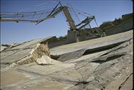
  Lower San Fernando Dam
   |  | 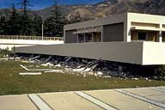
  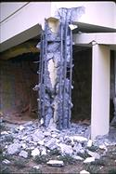 |  |  | 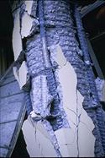
  Olive View Hospital
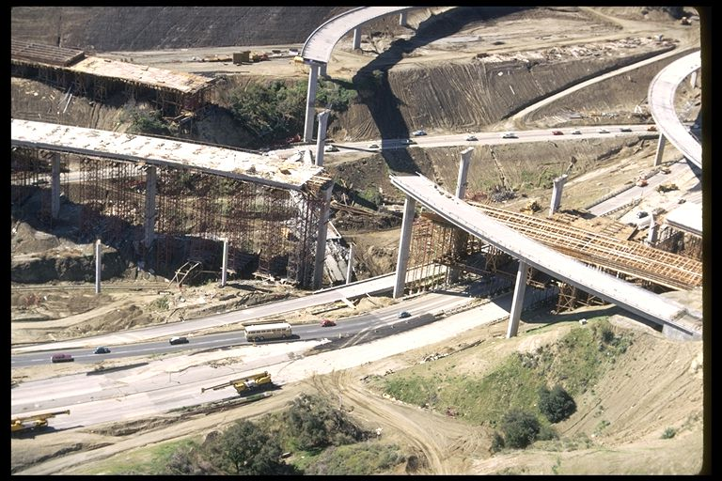 | 
Interchanges on I5

1971 | After the San Fernando earthquake, Caltrans doubled design forces for frames on spread footings; increased design forces on frames supported on piles by 2.5; and introduced ductile detailing; and initiated an aggressive research program in bridge earthquake engineering.
1978 | ATC-3-06 published, introducing modern concepts of earthquake engineering for buildings, including hazard characterization, dynamic analysis, and use of ductile detailing in steel and reinforced concrete components. ATC-3-06 was the forerunner of the NEHRP Recommended Provisions.
Recent damaging earthquakes in the United States (1989 Loma Prieta, 1994 Northridge) and abroad (1995 Kobe, Japan; 1999 Izmit, Turkey; and 1999 Chi-Chi, Taiwan) have led the public-at-large, public officials (local, state, and federal), and owners of structures (buildings, bridges, and infrastructure) to question the utility of modern seismic design codes. Many have argued that a higher level of public safety is required (despite the extremely low likelihood that an individual will die as a result of earthquake shaking).
Partially in response to the damage wreaked by the Loma Prieta and Northridge earthquakes, the Federal Emergency Management Agency funded studies on performance based earthquake engineering: studies that resulted in FEMA 283 (Moehle and Whittaker, Eds), FEMA 273 and FEMA 274: two documents that have been replaced by FEMA 356.
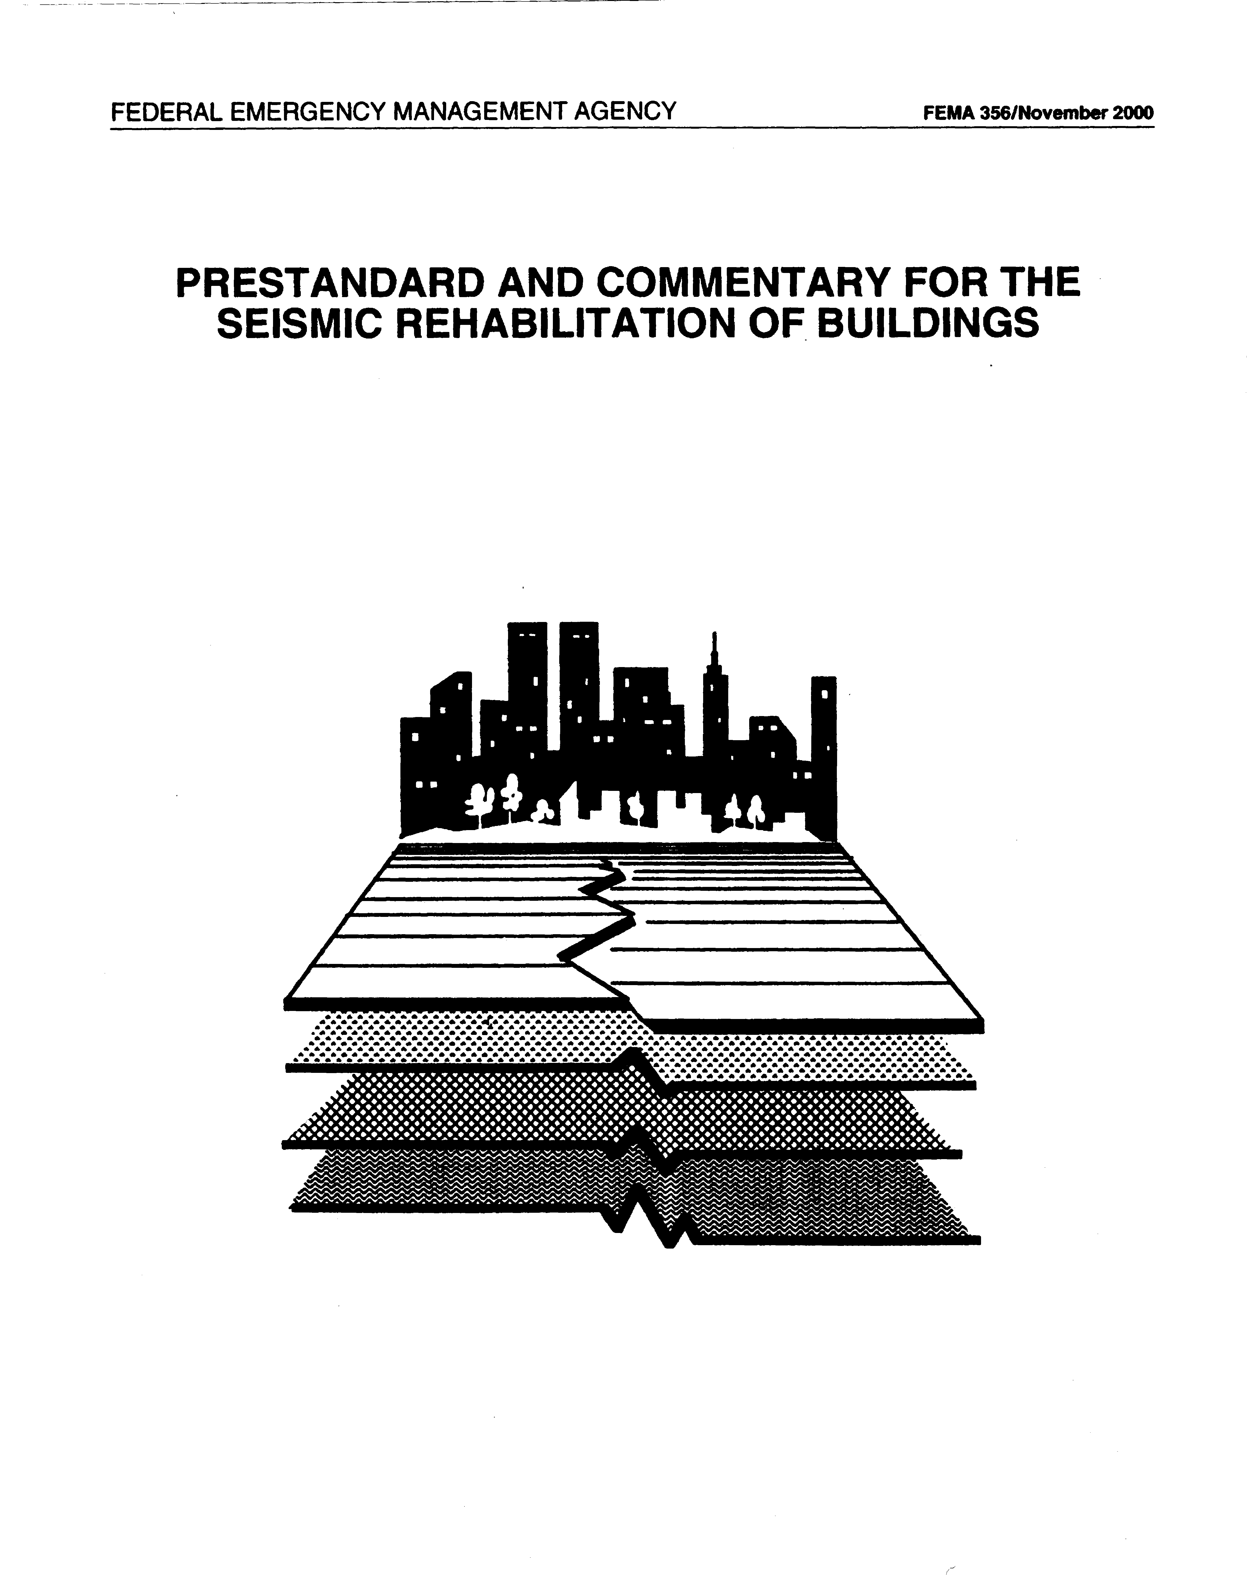
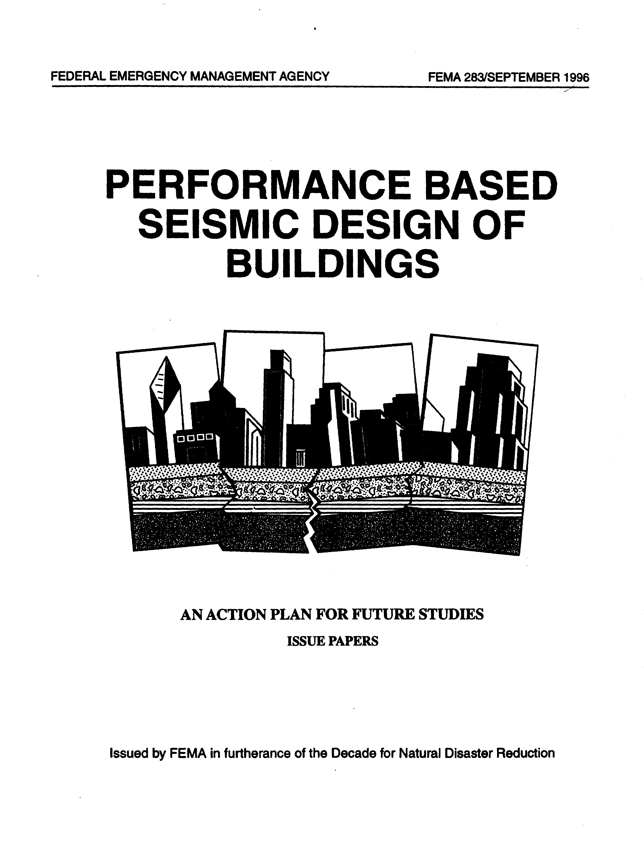

The past 10 years has seen rapid innovation in the practice of earthquake engineering. Examples include
- Computational tools, including
- IDARC (http://civil.eng.buffalo.edu/idarc2d50/)
- OpenSees (http://opensees.berkeley.edu/)
- SAP 2000 NL (http://www.csiberkeley.com/)
- 3-D BASIS (http://civil.eng.buffalo.edu/3dbasis/)
- Fast computational hardware that facilitates large-scale design-office simulation
- New methods for nonlinear analysis
- New hardware (seismic protective systems) and materials (composites).
Many of these innovations will be discussed this semester in CIE 619. These recent innovations facilitate the analysis and design of more complex soil-foundation-structure systems and real progress in the endeavor to deliver tools for performance-based earthquake engineering. Further, improved understanding of earthquakes, engineering seismology, and geotechnical engineering has led to new characterizations of earthquake hazard across the United States, with explicit account taken of (a) near-source effects (directivity and fling), (b) soil effects, and (c) strong-motion duration.
During this period, owners and insurance companies have been paying increased attention to potential losses following moderate-to-severe earthquakes, including
- Direct losses (cost to repair damage)
- Indirect losses (loss of income due to business interruption, etc)
As a result, performance expectations of owners and insurance companies are changing from preventing collapse to controlling damage but these end-users
- Cannot articulate their expectations (because they do not understand the issues at play)
- Don’t want to pay significantly more for improved performance
The following section presents the fundamental basis to earthquake resistant design, describes design philosophies, introduces uncertainty and randomness in the context of seismic design, describes different general procedures for design, and discusses the move toward performance-based earthquake engineering.

Design for Normal and Abnormal Loadings
The design process for gravity effects is relatively straightforward once a framing system and geometry are selected. The key steps for each component are as follows:
- Determine gravity loads on the component.
- Compute moments, shears, and axial forces in the component
- Size the component using either ACI 318 (for reinforced concrete) or the AISC LRFD provisions (for structural steel) thus ensuring that
Demand ≤ Capacity
where demands and capacities are measured in terms of forces.
- Check deflections (for beams). If acceptable, STOP. If unacceptable, select another cross section and return to step 1.
The design process for earthquake effects is not straightforward even after a framing system and geometry are selected because one component cannot be designed independently of the other components in the frame. Complexities include
  - Determination of global earthquake effects
  - Dynamic properties of the framing system (that are initially unknown)
  - Type of framing system
  - Distribution of the effects over the height of the structure
  - Different load patterns produce different demands on components
  - Modeling of the building frame
  - Centerline properties?
  - Cracked or uncracked properties?
  - Beam-column joint flexibility
  - Second-order effects?
  - Load combinations and component checking
Demand ≤ Capacity
where demands and capacities are measured in terms of forces for traditional design
  - But inelastic response is anticipated for a code-compliant building, so is this approach appropriate? Consider the global force-displacement relationship shown below.
Base shear

Roof displacement

Contrast here the objectives of analysis and design. The basic analysis paradigm that
Demand ≤ Capacity
requires the engineer to have already selected a framing system, developed a realistic mathematical model, established accurate estimates of the loads, and access to reliable (and accurate) computational tools. The basic design paradigm involves finding a solution (building design) that
  - Performs adequately under service (frequent) and severe environmental effects (wind, earthquake, blast)
  - Is insensitive to uncertainties in the loading
  - Is economical
How do we achieve the design objective? By first selecting the best framing system, executing the analysis paradigm using robust estimates of component capacities, developing construction documents that accurately reflect the results of the analysis and component-checking work (transferring a 3-d building into a series of 2-d images), and transferring the 2-d images into a 3-d structure using a workforce that is generally composed of a combination of skilled and unskilled labor.
Codes of practice are generally used as design tools for a number of reasons
- Serve as the standard of care (written by expert design professionals for design professionals)
- Provide a minimum standards for design to provide life safety (whatever that is)
- Legal protection
The stated mission of the code (IBC, 2000) is to
“…provide minimum standards to safeguard life or limb, property, and public welfare by regulating and controlling design, construction, quality of materials, use and occupancy, location, and maintenance of buildings.”
But do the seismic provisions of the codes deliver the intended performance? Are the codes, which were originally written for low-rise regular buildings of new construction, adequate for:
- Medium- and high-rise buildings?
- Irregular buildings?
- Non-structural components?
- Rehabilitation of existing buildings?
- A focus of many earthquake-engineering consultancies at this time.
- Delivering the intended performance?
- Performance is the objective but prescriptive formats are used instead of performance approaches
Recent earthquakes (Loma Prieta and Northridge) have left owners of buildings dissatisfied with the levels of performance delivered by modern seismic codes. Some examples include
  - Severe damage to new reinforced concrete buildings
  - Beam-column connection fractures in approximately 70% of steel moment-frame buildings in the epicentral region of the Northridge earthquake
  - Closure of buildings and hospitals due to the failure of architectural and mechanical (non-structural) components
One example of code-compliant but poor performance (as judged by others) from the Northridge earthquakes is shown below. This reinforced concrete building was demolished after the photograph was taken.

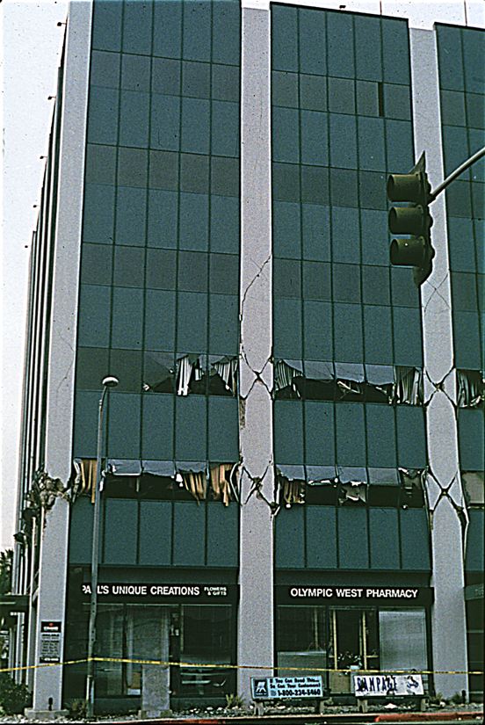
Efforts are under way to improve building codes and to develop new approaches to better reflect the wishes of the public-at-large, building owners, and government agencies. Incremental improvements to current practice are presented in
- International Building Code (a combination of the UBC, NBC and SBC)
- NEHRP Recommended Provisions for Seismic Design of Buildings by the Building Seismic Safety Council
- ASCE 7, Minimum Design Loads for Buildings and Other Structures
New approaches are being developed for performance based design and for retrofit construction, including those listed below
- SEAOC Vision 2000
- FEMA Performance-Based design (EERC)
- FEMA 356, Prestandard for the Seismic Rehabilitation of Buildings
- FEMA SAC Steel Project
Where is the profession heading at this time in terms of new approaches?
- Codes will likely continue to specify minimum standards
- Guidelines will be further developed to facilitate performance-based design and levels of performance in excess of those delivered by the codes
- May take 10 to 15 years to develop robust guidelines and even longer to gain widespread acceptance by design professionals
- Need to move new information into the profession by
  - Educating graduate students
  - Continuing education for design professionals
To address the complexities associated with designing and constructing buildings, bridges, and infrastructure to resist the effects of earthquakes, the engineer must possess a broad skill set that can integrate information from the following disciplines
- Architecture
- Engineering seismology
- Geotechnical earthquake engineering
- Structural design
- Structural analysis
- Dynamic analysis
- Risk and reliability analysis
- Construction and cost estimating
Information from the above disciplines must be integrated to deliver the performance sought by the owner (if in fact the owner is knowledgeable in this regard).
- Will minimum code standards be sufficient?
- Prescriptive (indirect) approaches with no assessment of performance: use this force, check this stress, adopt this detail, etc
- Is code+ performance required? If so, what are the performance objectives? How can this performance be delivered?
- Direct approaches are needed: state the performance objectives, proportion components, design components, and detail components to deliver the intended performance, evaluate the design, iterate as necessary until all the performance objectives are met.
The needs of both the analyst and the designer (perhaps the same person) must be met in order to deliver a performance-oriented product
- The analyst needs a toolbox to
- Analyze demands on the structure
- Analyze capacities of components (forces and displacements)
- The designer must manage uncertainty and risk
- Load and resistance factors
- Capacity design approaches to control inelastic dynamic response
- Procedures that focus on displacements and not forces
The content of this course will address some of the issues identified above including
- How can earthquake shaking be characterized and how do different ground motions affect the response of building structures?
- How can demands on framing systems be assessed using simplified techniques?
- How do different framing systems and materials behave under extreme loadings?
- How can the response of structural systems be made somewhat insensitive to earthquake shaking?
- How can new materials and technologies be used for new and retrofit construction?
However, before presenting information on these subjects it is worthwhile to reflect on the state-of-practice in the United States (with an emphasis on performance-based earthquake engineering) in terms of
- Seismic design philosophies
- Approaches to seismic design
- The design process

Seismic Design Philosophies

Performance Expectations of Modern Seismic Codes
The performance expectations of modern seismic codes such as the 2000 International Building Code, the 1997 Uniform Building Code, and the 2000 NEHRP Recommended Provisions are those traditional objectives first set forth in the SEAOC Blue Book, namely,
No. | Earthquake Intensity | Frequency of Occurrence | Performance Level
1 | Minor | Several times during life of building | No damage to structural or non-structural components (Immediate Occupancy)
2 | Moderate | Once or more times during the life of the building | Limited damage to structural components and no damage to structural components
3 | Severe | Rare event (as large as any measured at the site) | Limited damage to structural components; building egress maintained; no substantial loss of life (Life Safety)
4 | Major, Catastrophic | Very rare (as large as can be expected at the site) | No global collapse of building frame; partial collapses acceptable (Collapse Prevention)
These definitions of intensity, frequency, and performance are vague and subjective. What are moderate, limited damage, one or more times? How can performance be delivered at 4 levels if only level 3 is checked? Is the performance at all 4 levels consistent across the United States? In fact, does the code deliver performance objective 3?
- What is the technical basis for performance objective 3 and the corresponding code provisions?
The ambiguity in the definitions given in the above table leads to wide variations in (a) the interpretation of the codes of practice by design professionals, (b) the performance across structural framing systems, and (c) the performance by seismic region.
- Improved definitions and design approaches are needed

Uncertainties and Randomness in Seismic Design
Uncertainty and randomness are common to design for both gravity load effects and earthquake effects.
Consider first randomness. For gravity-load design, randomness exists in both the demands on the components and in the (strength) capacity of the components to resist the demands.
- How is randomness handled for gravity-load design?
For seismic design, randomness exists in both the demands on the structure and in the (deformation and strength) capacity of the structure to resist the demands. Earthquake motions are inherently random. Structural behavior (capacity) is affected by randomness in material properties and construction quality and by loading history and duration, which are in turn influenced by the randomness of the earthquake shaking.
Now consider uncertainty. Uncertainty exists in both the demand and the capacity of a component subjected to gravity loads and a structure subjected to earthquake shaking.
For demand on a structure subjected to earthquake shaking, uncertainties exist in the following areas
- Engineering seismology
- What intensity of shaking is expected at the site? What attenuation relationships are to be used? Do they apply in this instance?
- How is the shaking to be characterized? Elastic spectra? Earthquake histories?
- Directivity effects? Fling effects?
- Characteristics of earthquake shaking at the site in question
- Frequency content? Duration?
- Characteristics of the structural system
- Is the foundation modeled?
- What are the actual distributions of mass, stiffness, and strength in the building at the time of the shaking?
- Modeling of the structural system
- Is the model accurate for the likely response of the framing system?
- Centerline dimensions? Rigid-end offsets?
- Analysis and interpretation of the demand data
- What methods shall be used? Linear or nonlinear? Static or dynamic?
- Are the methods accurate? Can the chosen method capture the important behaviors?
For demand on a component subjected to gravity loads, uncertainties exist in what areas?

Uncertainties exist in the calculation of capacity of a component subjected to gravity loads. For gravity-load design, capacities are generally measured in strengths, which can often be predicted reasonably accurately, especially for components whose response is governed by flexure. However, flexural strength estimates can be complicated by slab contributions, connection details, shear force, axial force, and the presence of non-structural elements.
Uncertainties exist in the calculation of capacity of component and systems subjected to earthquake effects over and above the contributors listed above to the uncertainty of strength calculations, including
  - Emphasis on deformations and not strengths
  - Inelastic response in many components
  - Strength capacities at large deformations
  - Load-history dependent
  - Rate effects?
  - Deformation capacities much more difficult to predict than strength capacities
  - Load-history dependent
  - Capacities highly dependent on coexisting axial and shear forces
  - Translating component strengths into system strengths
  - Loading profile at critical instant?
  - Translating component deformation capacities into system deformation capacities
  - Displacement profile at maximum response?
  - Will failure of one or more components result in system failure?
All of these sources of uncertainty in both demand and capacity of components and systems subjected to earthquake shaking show that there is a need to de-sensitize the response of framing systems to uncertainties due to earthquake shaking and the dynamic characteristics of the frame. The question is how.

Limits States Design
Limit States Design (LSD) is widely used in Europe and has been adopted in the United States for gravity-load design. The AISC Load and Resistance Factor Design (LRFD) is a limit states approach to design.
LSD involves precise statements related to limiting states of response (performance levels), relationships between qualitative performance descriptors and quantitative response values (how the engineer checks for performance, statements of performance criteria (generally expressed as an acceptable probability of exceeding the criteria), and explicit recognition of randomness and uncertainty (see above). The table and figure below (adapted from Mahin 1999) illustrate the approach.
Limit State | Performance Level | Performance Criteria | Probability of Exceeding Performance Criteria
1 | Goal 1 | Demand-1 less than capacity-1 | % in years
2 | Goal 2 | Demand-2 less than capacity-2 | % in years
As suggested in the fourth column of the above table, it is not sufficient to just say that the average demand is less than the average capacity, but rather a probability of failure must be defined. In this case the probability of failure is usually described as x% probability of failure (not meeting the criteria) in y years, where y is the assumed service of the structure. Consider the figure below.
Frequency of occurrence

Demand
Capacity

Response parameter
Failure probability

In the AISC LRFD document, load factors on demand and resistance factors on capacity are used to provide a certain probability of failure. For details, see Nowak and Collins (2000). The basic design (strength) equation is
A limit states format is often used in current approaches to performance-based design (e.g., FEMA 356) because it can be used to capture the uncertainties associated with both demand and capacity. Uncertainties in demand on a structure arise from
- Earthquake shaking: treated using probabilistically based response spectra
- Structural response: within a family of earthquake histories with similar characteristics
- Methods of analysis: linear or nonlinear
- Modeling of components and systems: variations will lead to uncertainties in response (demand)
Uncertainties in capacity of a structure arise from
- Strength and deformation capacities after repeated cycling
- How should these capacity quantities be defined?
- Brittle failure modes
- Relationship between component deformations and system displacements
- Relationship between component failure and system failure

Uncertainty is normally handled by a probabilistic analysis. In general, the problem should be stated as x% chance of exceeding the performance goal in y years, but this is a complex problem to solve rigorously. More often, the problem is approached as x% chance of exceeding the performance goal for an earthquake with a z% probability of occurrence in y years, which allows the engineer to treat the structure and the ground motion separately. How is this done? A probabilistic response spectrum can be coupled with a conservative deterministic design, or a calibrated load and resistance factors can be developed using Monte Carlo simulation (Nowak and Collins, 2000) or reliability analysis to deliver the target reliability.
One step in the above process is to characterize earthquakes with a z% probability of occurrence in y years. This can be done using estimates of selected ground motion parameters, elastic response spectra, and earthquake histories.
The table below (adapted from Mahin 1999) presents the three-tier limit state format that can be found in the earthquake-engineering literature. The three limits states are Service, Damage, and Ultimate. Comments on the three limit states follow the table.
Limit State | Objectives |  | Performance Criteria | Probability of Seismic Event | Probability of Exceeding Performance Criteria
Limit State | Functional | Damage-related | Performance Criteria | Probability of Seismic Event | Probability of Exceeding Performance Criteria
Service | Continued occupancy w/o business interruption. | No significant damage | Stresses less than yield, limited accelerations, displacements and drifts less than threshold values | % in years  (50% in 50 years) | % in years  (0.1% in 30 years)
Damage | Structure can be returned to service following modest repairs, some business interruption | Limited damage to nonstructural components and no significant damage to structural components; structure can be repaired | Stresses may exceed yield limit, displacements and drifts exceed damage threshold | % in years  (20% in 50 years) | % in years  (0.2% in 30 years)
Ultimate | No substantial loss of life | No global collapse of structure, structure could be returned to service after repair | Plastic deformations with rotations less than capacities, limit drifts to avoid instability, limit rotatoins and energy dissipation to components or regions that can be repaired | % in years  (5% in 50 years) | % in years  (0.3% in 30 years)
The service limit state is the best defined of the three limit states because elastic response in the structural and non-structural components is mandated. Performance limits such as drift are generally dictated by the elastic response of (brittle) no structural components.
The damage limit state is that range of response between the service and ultimate limit states and is not crisply defined. Damage in this range should be repairable but often decisions to repair are more financial in nature than technical. What is repairable? Also, issues related to business interruption are important in this range of response because the cost of business interruption (loss of income, loss of tenants, etc) may far outweigh the costs of repair.
The ultimate limit state is principally associated with (preventing) the global collapse of a structure and avoiding large loss of life (that often follows global collapse). Key to any discussion associated with this limit state is the earthquake characterization
- 10% in 50 years (traditional practice for commercial construction)
- 2% in 50 years (used for hospitals and EOCs)
- 1% in 100 years (used for nuclear and defense-related facilities)

Performance Based Earthquake Engineering
SEAOC Vision 2000
Vision 2000 (SEAOC, 1995) was prepared by the Structural Engineers Association of California as a first step toward improving current seismic design codes such as the 2000 IBC, 1997 UBC, and 2000 NEHRP Recommended Provisions. An important first step was the development of a performance matrix that is reproduced below.
 |  | Performance Objective
 |  | Fully Operational | Operational | Life Safe | Near Collapse
Earthquake Probability | Frequent |  |  | Unacceptable Performance
Earthquake Probability | Occasional |  | 
Earthquake Probability | Rare |  |  | 
Earthquake Probability | Very Rare |  |  |  | 
 |  Basic facilities
 |  Essential or hazardous facilities (hospitals, EOCs, refineries)
 |  Safety critical facilities (nuclear installations, national defense)
What are the implications of this performance matrix?
- Less damage to safety critical facilities than basic facilities for a given level of shaking
- Increased amount of damage for more severe shaking
Is this matrix reasonable? It depends on how performance and earthquake probability are characterized. Vision 2000 proposed the following definitions for seismic damage states (see above figure) and earthquake probability.
Limit State | Description of Damage
Fully operational | No damage, continuous service
Operational | Most operations and functions can resume immediately. Repair is required to restore some non-essential services. Damage is light. Structure is safe for immediate occupancy. Essential operations are protected.
Life safe | Damage is moderate. Selected building systems, features or contents may be protected from damage. Life safety is generally protected. Structure is damaged but remains stable. Falling hazards remain secure. Repair possible.
Near collapse | Structural collapse is prevented. Nonstructural elements may fall. Repair generally not be possible.
Collapse | Complete structural collapse

Earthquake classification | Recurrence interval | Probability of occurrence
Frequent | 43 years | 50% in 50 years
Occasional | 72 years | 50% in 50 years
Rare | 475 years | 10% in 50 years
Very Rare | 970 years | 10% in 100 years
Recommendations regarding maximum permanent and transient drift (% of story height) are also listed in Vision 2000:
Limit State | Maximum (transient) drift (%) | Maximum permanent drift (%)
Fully operational | 0.2 | Negligible
Operational | 0.5 | Negligible
Life safe | 1.5 | 0.5
Near collapse | 2.5 | 2.5
Collapse | >2.5 | >2.5
Vision 2000 made important proposals and recommendations to the earthquake engineering community regarding the future of design practice. Although Vision 2000 serves as a valuable resource document, it has several shortcomings that include
- No technical basis (risk assessment) associated with the performance matrix
- Subjective definitions for the performance limit states
- No analytical approaches proposed to deliver the intended performance
- Approach is somewhat uncoupled
- A deterministic design procedure is linked with a probabilistically determined spectrum
- No technical basis for the displacement limits
- Does a building collapse when the drift exceeds 2.5%?
FEMA 356, Prestandard for the Seismic Rehabilitation of Buildings
In 1997, the Federal Emergency Management Agency (FEMA) published resource documents FEMA 273 and FEMA 274, guidelines and commentary, respectively, for the seismic rehabilitation of buildings. These two documents have recently been combined into one pre-standard, FEMA 356.
Although FEMA 356 was written to aid in the evaluation and retrofit of existing buildings, the procedures contained in the FEMA 356 can be applied directly to new construction, because acceptance criteria are provided for materials and details required by modern seismic codes.
FEMA 356 represents a radical departure or paradigm shift in the practice of earthquake engineering in the United States. Key features of FEMA 356 include
- Four performance levels
- Operational
- Immediate occupancy
- Life safety
- Collapse prevention
- Earthquake hazard characterization using the USGS National Seismic Hazard Maps
- Spectrum defined for 5% damping at T = 0.2 second, and 1.0 second
- Displacement-based methods of analysis
- Linear Static Procedure (LSP) and Linear Dynamic Procedure (LDP)
- Nonlinear Static Procedure (NSP) and Nonlinear Dynamic Procedure (NDP)
- Displacement-based component checking procedures
- Deformation and force capacities presented for different performance levels for new and existing (old) construction
FEMA 356 will be discussed at length in this class later in the semester. Because FEMA 356 is not a code of practice but rather guidelines for seismic rehabilitation of buildings, no performance objectives are mandated for retrofit construction, although building collapse should be avoided in a very rare earthquake. FEMA 356 addresses some of the shortcomings of Vision 2000 (recognizing that the writers of Vision 2000 never intended to draft new analysis methods, etc.), namely,
- No performance matrix is mandated
- Qualitative descriptors of performance have been assigned quantitative values at the component level
- Limited technical basis for many of the response limits
- New analysis methods have been implemented to deliver the intended performance
- No displacement limits are specified in FEMA 356
SAC Steel Project
The SAC (SEAOC-ATC-CUREE) Steel project was a joint venture whose primary mission (in Phase 2 of the project) was to develop a performance-based engineering approach for the design and construction of new steel moment-resisting frames. The work of the SAC project built on FEMA 273 and 274.
Key features of the SAC project include
- Two performance levels
- Incipient damage (elastic response, low drift)
- Incipient collapse (global instability)
- Multiple earthquake probabilities
- 50%, 10%, and 2% in 50 years
- Consistent reliability approach (see Hamburger, 1998)
- Developed and evaluated using a large-scale Monte Carlo simulation effort
- Includes a treatment of randomness and uncertainty to focus on confidence of achieving the performance goal during the specified period
- Rational load, resistance, and bias factors are used to handle uncertainties
Mahin (1999) describes the basic approach as follows:
or by combining terms and adding the confidence level
The SAC approach is a multi-level approach and includes (a) a code approach with specified demand, capacity, and confidence values, and (b) methods permitting nonlinear analysis and testing to develop demand and capacity values, or to specify different target confidence levels.
Mahin (1999) outlines the design procedure for new steel moment-frame buildings as follows:
- Select performance level and earthquake probability (e.g., Incipient Damage and 50% in 50 years)
- Determine seismic hazard for the earthquake probability of 1., generally a spectral displacement at the fundamental period of the building
- Develop a mathematical model of the framing system
- Analyze the mathematical model to determine the values of the key design parameters
- Apply demand and bias factors to the values of the design parameters from 4. to compensate for the biases and uncertainties inherent in the predictive methodology (linear versus nonlinear method of analysis) and the randomness inherent in structural response to earthquake effects. Apply an additional demand factor to achieve the desired confidence level.
- Compare the factored demand against the factored acceptance criteria for the design parameter: .

Seismic Design Practice
Mahin (1999) writes “…a few homilies to keep in mind regarding the design process are
- A design is only as good as the structure.
- You can’t make a silk purse from a sow’s ear.
- The level of engineering must be reflected in the details.”
All in all, this is good advice, especially bullet item 2. No level of sophisticated analysis will transform a poorly configured lateral framing system into a robust framing system. What is meant by bullet item 3?

The basic parts of the design process are shown below. This chart oversimplifies the design process to be sure but can be used to introduce aspects of design.
Functional Requirements
Site Evaluation
Select Structural System
Engineering and Construction Documents
Quality Assurance and Control

Functional requirements for a building structure include
- Loading environment (dead, live, wind, earthquake, blast)
- Performance criteria for gravity (deflections, stresses) and environmental (damage, displacements, and collapse) loads
- Geometric (space) requirements (often driven by architecture)
- Time available for construction
Site evaluation for a building can include the following
- Proximity to unacceptable risks (earthquake fault zone, liquefiable zones, steep slope)
- Geotechnical investigation (bearing pressures, pile sizes, pressures on walls)
- Seismic hazard characterization
During pre-schematic (or pre-scheme) design, several alternative framing systems are generally considered. This phase of the work may include preliminary design that has been assigned to the engineering phase for this presentation. Factors that drive the final choice of a structural system include
- Cost
- Architectural flexibility

- Performance in scenario earthquakes (likely damage, deformations, etc)
- Cost
The engineering and construction documents phase of a project can include
- Preliminary or schematic design (20% of total effort)
- Key step in the design of a building (see homily number 2 above)
- Regular structure of good proportions
- Complete (and short) load paths from the roof to the foundation
- Well-proportioned distribution of lateral stiffness and strength
- Iterative process for multiple performance objectives
- Frequent, occasional, rare, and very rare earthquakes
- Prepare cost estimate
- Commence peer review
- Design development (30% of total effort)
- Linear analysis of the framing system to help size components
- Simple nonlinear analysis to evaluate framing system and components sized using linear methods
- Consideration of multiple performance objectives
- Refine member sizes and develop standard details
- Develop floor spectra for non-structural components
- Trial details for architectural façade elements
- Finalize floor plans and structural framing elevations
- Continue peer review
- Prepare cost estimate
- Construction documents (50% of total effort)
- Finalize analysis and construction details for multiple performance objectives
- Iterate as necessary
- Complete structural drawings and coordinate with other disciplines
- Write specifications
- Finalize peer review
- Prepare cost estimate
- Quality control and quality assurance
- Critical phase in the delivery of a performance-oriented product
- Contractor should have an in-house QA/QC program
- Owner should retain an independent QA/QC program that includes on-site observation and shop inspection (steel and precast components)

Seismic Design Methods and Procedures

Introduction
There are various approaches or strategies used by engineers to control accelerations (construction cost), displacements (and damage) in building frames during earthquake shaking. Some of these approaches are discussed briefly below.
For the purpose of this presentation, two classes of structural framing systems are considered
- Elastic framing systems
- Make the system stiff and strong enough to remain elastic during the design earthquake
- Expensive
- Not used unless safety-critical facility (such as a nuclear power plant) but must consider downsides
- Nonstructural component response?
- What happens to the framing system during a maximum earthquake? Catastrophic collapse?
- Inelastic framing systems
- Nonlinear fuses to control response
- Plastic hinges in structural components, damping devices, seismic isolation
- Ideally force energy dissipation (damage) into components that are not part of the gravity-load-resisting system
- Controls forces (and accelerations) in framing systems
Force
Displacement
Force limits
h

- How are accelerations controlled?
- Assume that the force limit is , that the stick forms a bilinear plastic hinge at its base at moment , and that the mass of the oscillator is m
- How are and related?
- Consider now the dynamic equilibrium of this oscillator and ignore the effects of damping
  - The major challenge with inelastic or nonlinear systems is to calculate the deformation or displacement demands
  - Displacement-based design: one focus of this class
  - Nonlinear spectra
  - Estimates based on elastic displacements with empirical multipliers
  - Nonlinear static analysis for local deformation estimates
  - Nonlinear dynamic analysis for global and residual displacements

Allowable Stress or Working Stress Design
Allowable Stress Design (ASD), also known as Working Stress Design, is used in older codes for seismic design in the United States but has been abandoned in large part at this time. For reinforced concrete structures, the ultimate-strength-design provisions of ACI 318 are used for seismic design. The shortcomings of this traditional approach are
- Lateral loads are unknown so the costs of keeping the framing system in the elastic range become extremely prohibitive
- Failure modes of components are not considered
- Reserve strength in flexure and shear may be substantially different: say 1.1 for shear and 1.5 for flexure.
- Impact?

Capacity Design
Capacity design was first proposed in 1961 by Blume, Newmark, and Corning (with significant contributions by Sozen). Paulay and Park further developed these concepts in New Zealand in the 1970s. The basic strategy is to proportion the component to fail in a ductile manner (flexure) by making the capacity in other modes greater. Consider the beam from a reinforced concrete moment-resisting frame shown below (from ACI 318). The design shear force is calculated using the plastic moments at each end of the beam, where these moments are based on the rebar provided in the beams and rebar stresses greater than . The capacity design procedure works well for beams (as shown below) and beam-column joints (as discussed in CIE 525), but does not always work well for columns (as discussed in CIE 525). Also, only component behavior is considered and no consideration is given to system response.
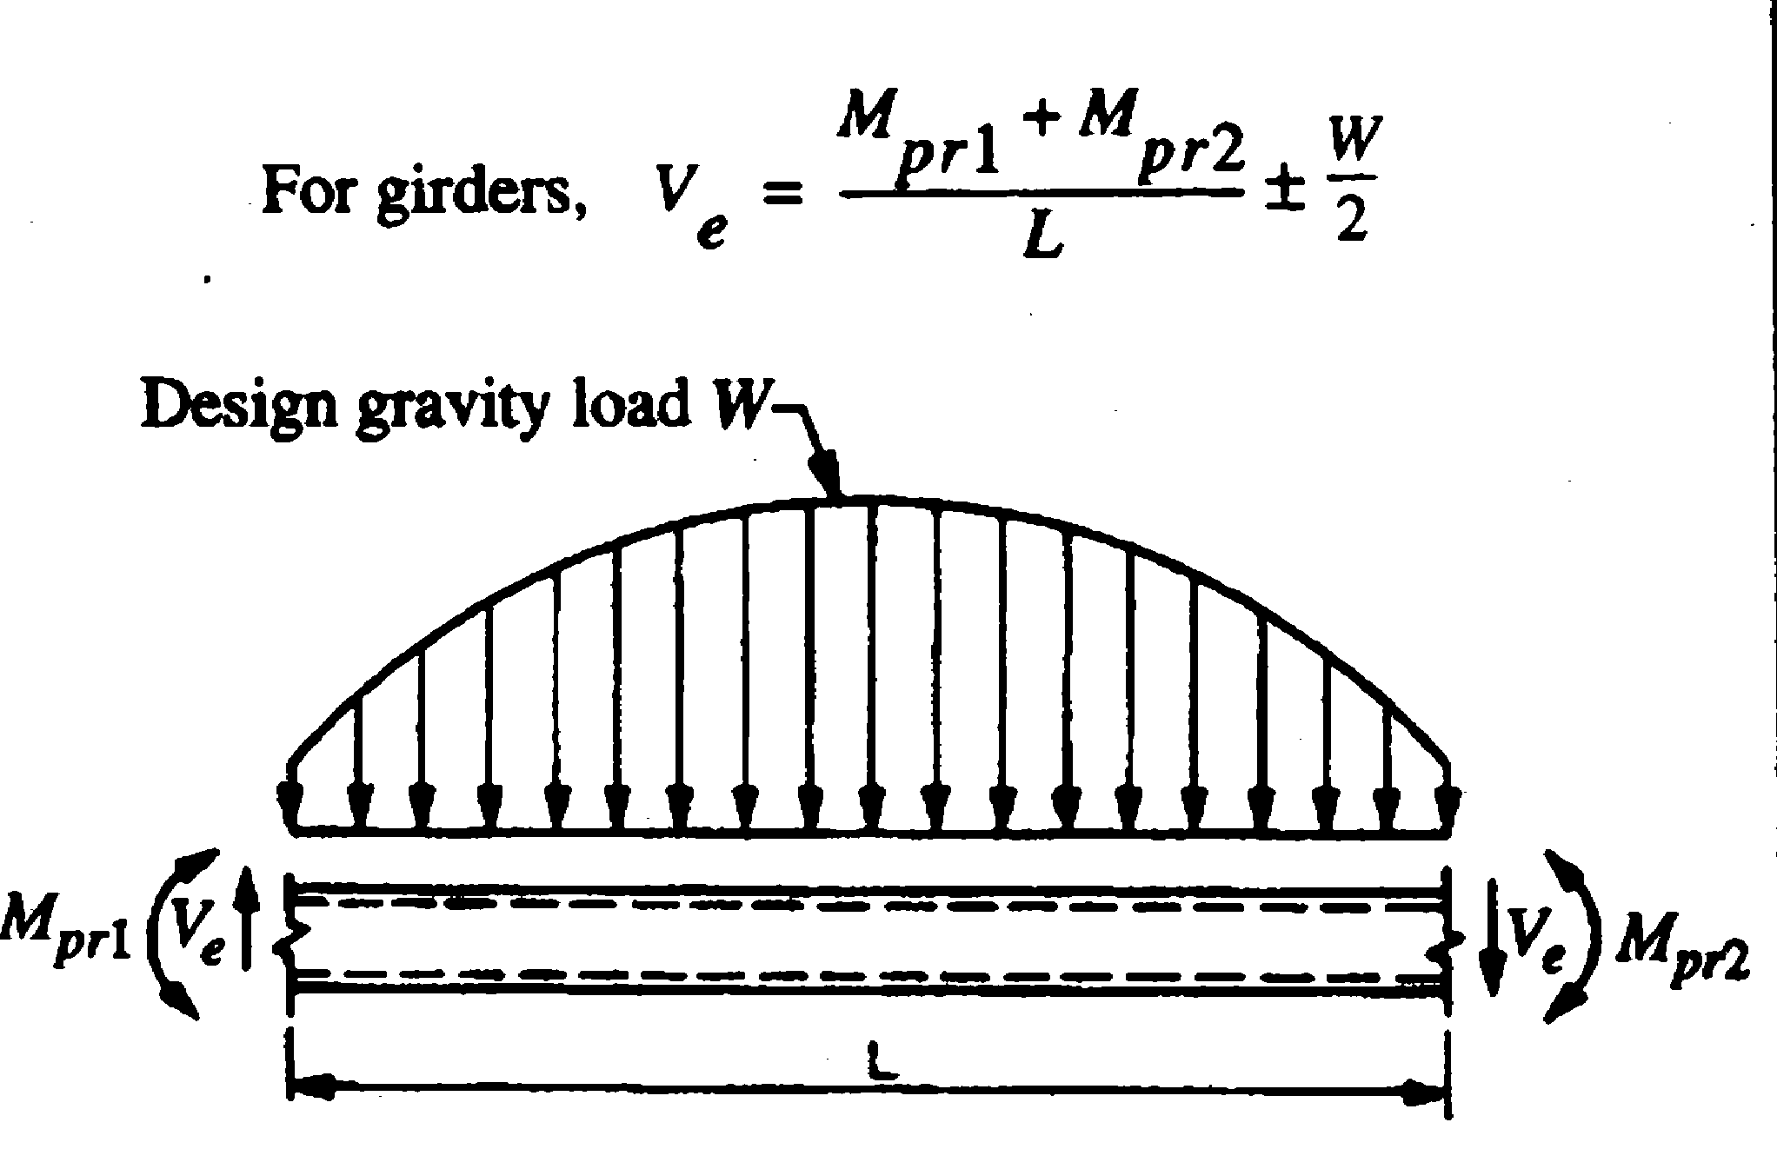

Damage Tolerant Design
Damage tolerant design serves to provide alternate load paths through framing systems for gravity and lateral loads. Damage tolerant design originated from blast loading considerations in the 1950s and considerations of the progressive collapse limit state. Two examples of damage tolerant structures are shown below: one building damaged (but standing) following the 1999 Izmit earthquake and one building damaged by falling debris from the No. 2 World Trade Center.
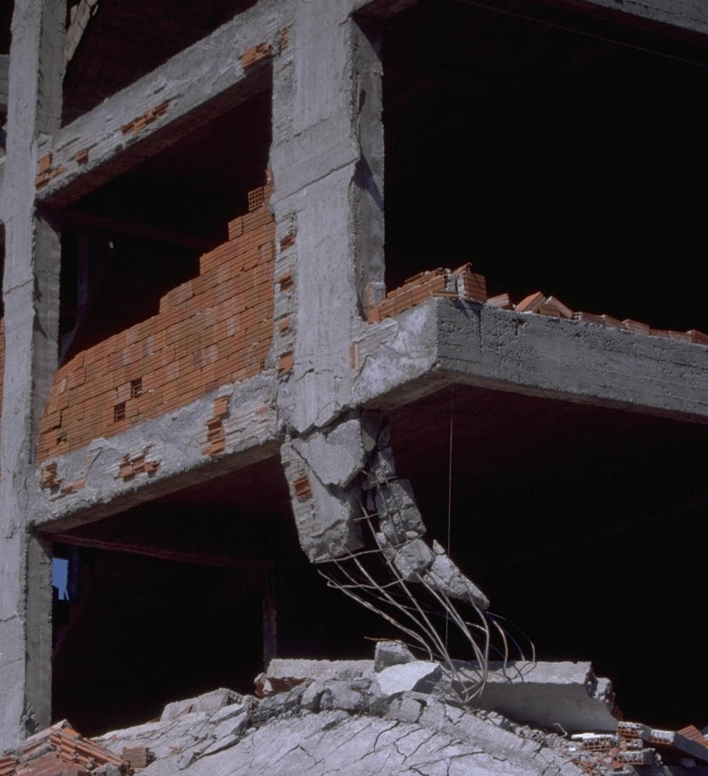 | 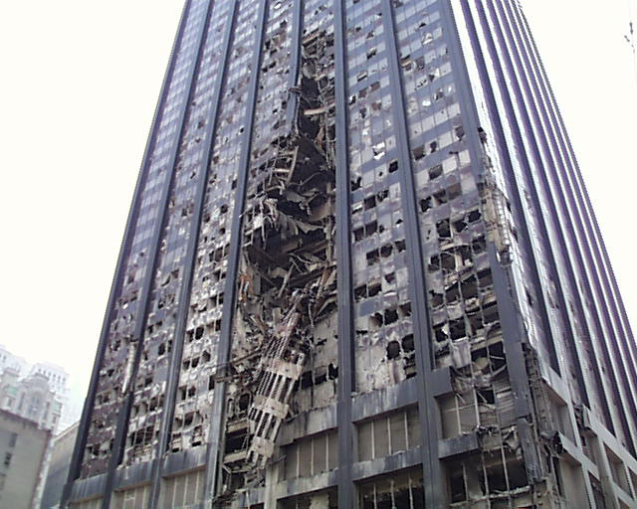
Izmit, Turkey, 1999 | New York, New York, 2001

Displacement-Based Design
As noted previously, procedures for displacement-based design (more correctly displacement-based evaluation) will be developed in detail in this class. In summary, global displacements are determined using either direct or indirect procedures, and interstory drifts, floor accelerations, and component deformations are back calculated from these global displacements. Component deformation demands are then compared with component deformation capacities and strength and deformation demands on non-structural components are compared with the corresponding response limits. Key to the success of this method is the correct calculation of global displacements.

